**VIVA VOICE (ORAL EXAMINATION)**

**Table of Contents**

1) Introduction 3

2) Overview of BrewDog 3

a. Rationale 3

b. Associated Disruptive Innovation 4

c. Company Background 5

3) Approach towards Strategic Analysis 6

a. Applied Tools, Theories and Frameworks 6

i. Tools 6

ii. Theories 7

iii. Frameworks 8

b. Contribution of Group Members 9

4) Findings from Analysis 10

a. Results from the Application 10

i. Strategy and Strategic Approach 10

ii. Evidence of Planning 11

iii. Issues from the Implementation 12

b. Insights from the Analysis 13

i. Sustainable Competitive Advantage (SCA) 13

ii. Possible Key Issues 14

c. Conclusions and Recommendations 16

i. Things Done Currently 16

ii. Things to be Considered Differently 17

iii. Key Competitive Threats 17

5) Reflective Evaluation 18

a. Possible Challenges Encountered 18

b. Things to be Done Differently 18

Reference List 19

# 1) Introduction

The concept of disruptive innovation is attributed to creativity transforming highly sophisticated or expensive services or products. It makes certain that the offerings previously accessible to more-skilled or high-end consumer segments are now accessible and affordable to a broader population. Elicited from this information, the following group presentation is focused on understanding the emerging disruptive innovation in the craft beer industry. This is focused on analysing the recent sustainability challenges incurred by ***BrewDog*** and its negative brand image. It is also aimed at recommending possible disruptive innovation for future sustenance and gaining a sustainable competitive advantage.

# 2) Overview of BrewDog

## a. Rationale

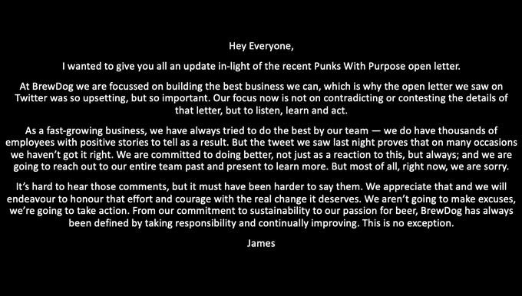

**Figure 1: BrewDog’s Response Tweet**

(Source: Race, 2021)

* BrewDog has been subject to a range of criticisms over the past many years with the recent one being accusations from its previous employees.
* This is concerning the review provided by about 60 former employees of this company accusing the brand of maintaining a misogynistic and toxic workplace culture (Race, 2021).
* However, the brand also counters this criticism with the belief that there tends to be a “distant gap” between the perceptions of former employees and the current ones.

The following sustainability concern for BrewDog is accompanied by former employees concerning this brand stating that a significant number of the workers have been subject to suffering from mental illnesses. This craft beer brand is identified to have faced acquisitions on grounds of its culture and processes failing to adapt to its market growth (Race, 2021). It was also mentioned that there was inadequate human resources support, insufficient resources and underprepared leadership causing challenges.

## b. Associated Disruptive Innovation

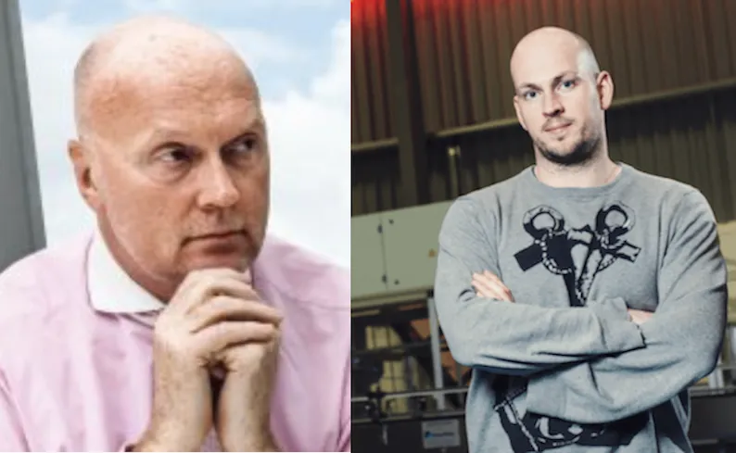

**Figure 2: Allan Leighton and James Watt**

(Source: Murden, 2022)

* As a response to the criticism faced by BrewDog, Watt accounted for addressing a range of reforms for regaining the brand image.
* A leading innovation in this context was appointing Allan Leighton as a chairman with a blue-chip reputation in addition to being a chief executive for Asda and Pandora and chairman of Co-op (Fraser, 2021).
* This was a crucial move for stabilising BrewDog ahead of a stock exchange float in addition to mentoring its chief executive.

Leighton’s belief of BrewDog having built an incredible market position with a crucial sustainability history could be contributing towards the right governance in place for capitalising on potential opportunities (Murden, 2022). This was accompanied by a 3% rise in pay in addition to hiring more staff to reduce the pressure on existing employees.

## c. Company Background

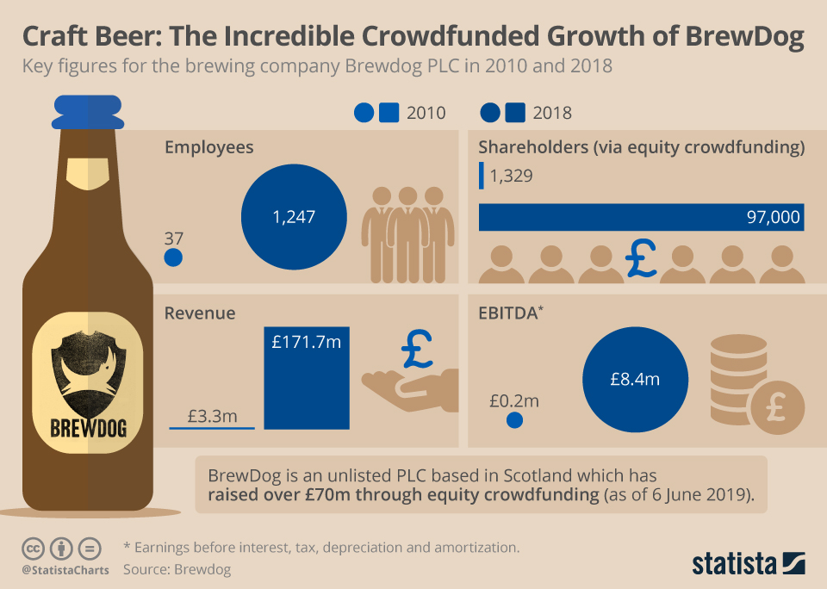

**Figure 3: Crowdfunded Growth of BrewDog**

(Source: Armstrong, 2019)

* BrewDog has established itself as a multinational brewery with headquarters in Ellon, Scotland and a production rate of over 800,000 hectoliters (BrewDog, 2023).
* A core element concerning the quick success story of this brand is its crowdfunding way for financing rapid expansions.
* This was followed by the first round of introducing *“Equity for Punks”* in 2010 and allowing anybody to invest and join the “craft beer revolution”, thereby raising more than £70 million (Armstrong, 2019).

Scottish-based BrewDog was founded in 2007 following about 50% of the top 10 craft beers in UK being sold in retail as BrewDog branded products. In addition, the off-trade market share for BrewDog makes a close count of about 21% (Conway, 2023). Concerning the phase of 2015 to 2019, on-trade sales of craft bears have witnessed a growth of about half a million hectolitres in UK.

# 3) Approach towards Strategic Analysis

## a. Applied Tools, Theories and Frameworks

### i. Tools

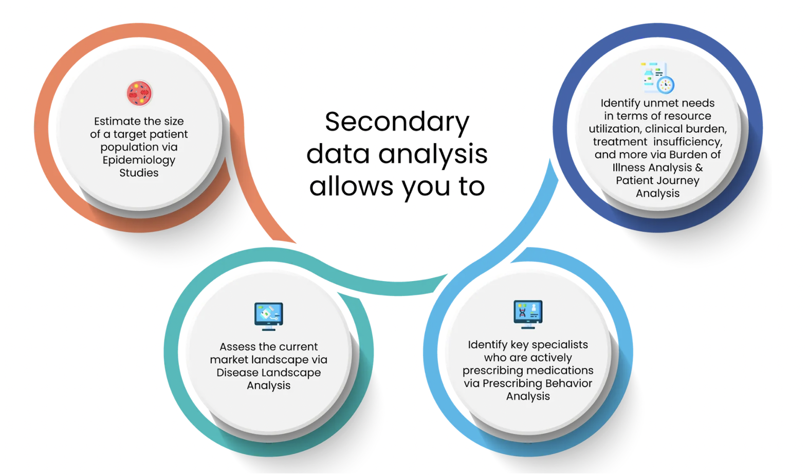

**Figure 4: Secondary Qualitative Data**

(Source: Influenced by Lester *et al*. 2020)

* The following study has been subject to using secondary qualitative data for addressing the key purpose.
* Lester *et al*. (2020) asserted that qualitative research has a potential advantage in terms of rendering heterogeneity and diversity.
* This has helped with establishing quality while cleaning rigour for all the presented arguments.

The particular attribute of using secondary quality data has helped with gathering relevant information regarding the context of BrewDog through published academic sources and relevant newspaper articles. Aguinis and Solarino (2019) argued that insufficient transparency is substantially pervasive regarding qualitative research studies. In this regard, the following study has accounted for using a constructor search strategy with inclusion and exclusion factors for maintaining authenticity and credibility.

### ii. Theories

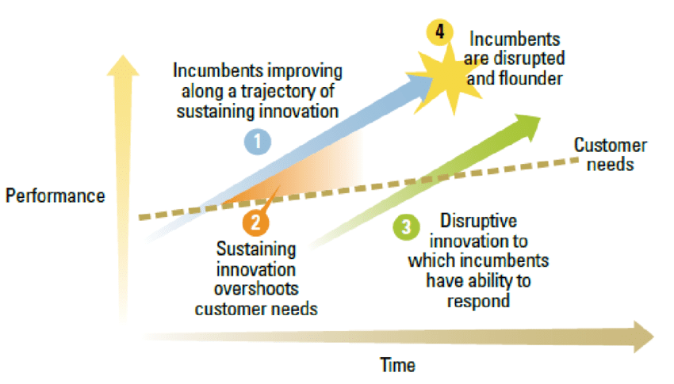

**Figure 5: Disruptive Innovation Theory**

(Source: Influenced by Si and Chen, 2020)

* Relevant to business theory, the context of disruptive innovation refers to innovation subject to creating a value network and new market or entering at the bottom of an existing market.
* This directs the way for eventually displacing established market-leading products, alliances, and firms.
* Si and Chen (2020) opined that the “disruptive innovation theory” is an incumbent of desired resources for challenging established businesses and eliminating obstacles in the process of its growth.

Application of this theory can be prominent for BrewDog in innovating and developing its offerings to appeal to its most demanding and profitable customers. It is also contradicted by Si and Chen (2020) that disruptive innovation tends to be doubtful for companies specifically focusing on incumbents. Regarding this issue, a common question for BrewDog can be if its incumbents require a proactive response or adoption of disruptive innovation.

### iii. Frameworks

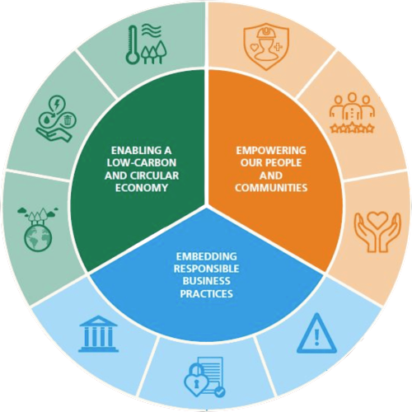

**Figure 6: Sustainability Framework**

(Source: Influenced by Mio *et al*. 2020)

* Sustainability Framework accounts for providing the baseline matrix for the demonstration of environmental impact.
* It also helps with monitoring ESG performance while defining and formulating relevant strategic commitments.
* Mio *et al*. (2020) pointed out that sustainable goals address all factors of society with particular importance for businesses.

Sustainability frameworks leverage the scope for businesses to have a road map regarding their operations in a way that can be socially responsible, economically viable and environmentally friendly. Compliance with this attribute can be beneficial for BrewDog in ensuring a sustainable future along with potential ethical governance.

# b. Contribution of Group Members

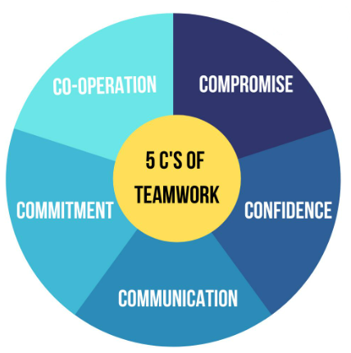

**Figure 7: 5Cs of Communication**

(Source: Karan, 2022)

* A significant group work attribute followed for carrying out this research aspect is effective teamwork and communication.
* This has involved compliance with the 5Cs Framework regarding teamwork (Karan, 2022).
* Hence, this has contributed towards extensive research regarding the subject, gathering relevant data and presentation along with effective proofreading.

Counting on a strong sense of cooperation and confidence has resulted in promoting an amount of clarity along with a transparent working approach for addressing the objectives of the study. In addition, a strong sense of compromise, commitment, and communication has been effective in prioritising the interests and needs of teamwork over personal interests.

# 4) Findings from Analysis

## a. Results from the Application

### i. Strategy and Strategic Approach

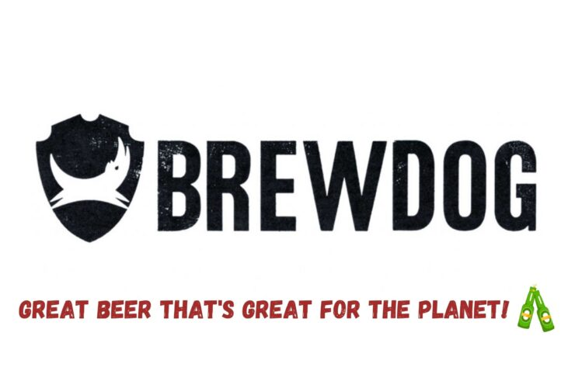

**Figure 8: BrewDog’s Marketing Strategy**

(Source: Samaniya, 2022)

* BrewDog tends to be based on an “anti-business” business model in terms of staying small (Samaniya, 2022).
* This is also followed by the brand having a special seeding point that distinguishes itself from other competitive breweries.
* In addition, BrewDog maintains an online network with a collective of 14 shows including cocktails, comedy, food, travel, and others (Samaniya, 2022).

BrewDog’s strategic mission involves *“making people as passionate about beer as we are”* (Samaniya, 2022). This is also accompanied by a charter of *“For better beer. For a better planet. Powered by people. For us all”*. Both these charter and mission enable scope for BrewDog in carrying out its marketing campaigns while attracting target customers.

### ii. Evidence of Planning

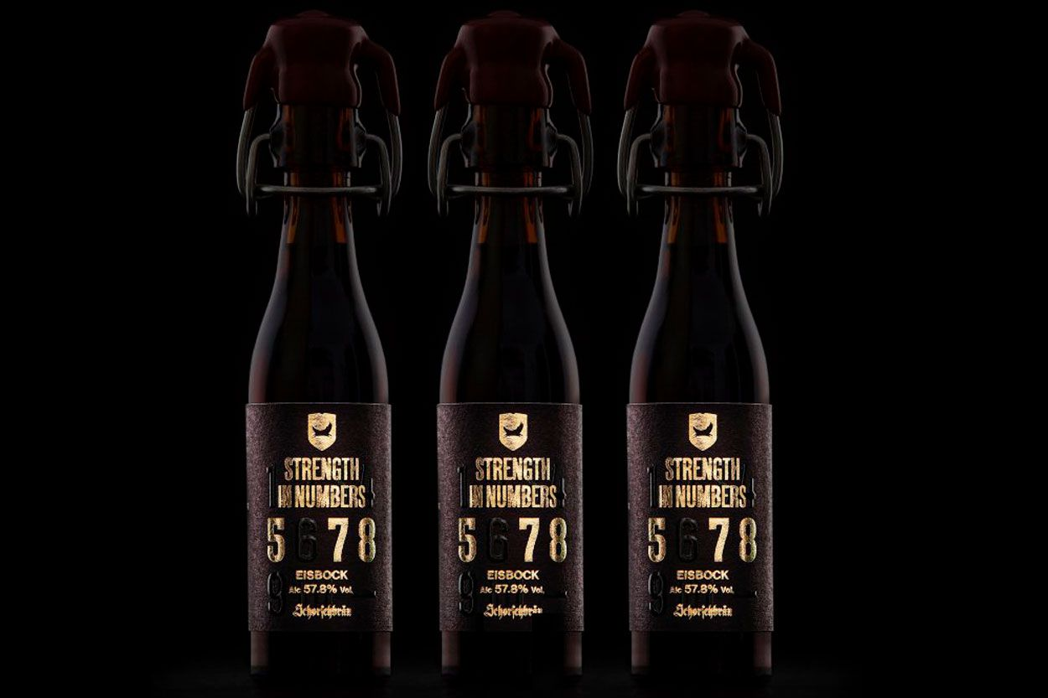

**Figure 9: *“Strength in Numbers”* Beer**

(Source: Stone, 2020)

* BrewDog is identified to be caring for its people by keeping a check on their requirements and needs, thus maintaining a “community tab” for its people on its website.
* This brand also has the adoption of a climate-conscious scheme that ensures its audience indulges in protecting the environment while also rewarding them for the same (Samaniya, 2022).
* BrewDog is also subject to earning diverse labels with the common one being *“Strongest UK brewed beer, World’s strongest beer, First beer brewed at the bottom of the ocean”* (Stone, 2020).

This is relevant to the context of BrewDog joining forces with German brewery - Schorschbräu, for creating “strength in numbers”. The following brand at 57.8% ABV is addressed as one of the strongest beers, following the traditional Eisbock brewing method.

### iii. Issues from the Implementation

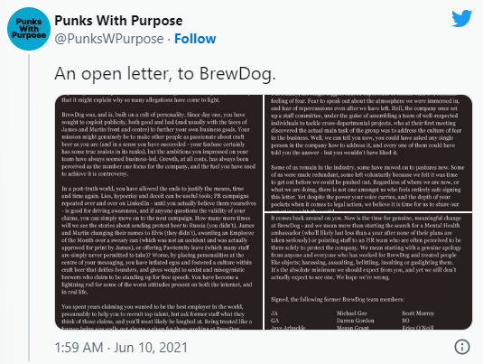

**Figure 10: Challenges faced by BrewDog**

(Source: Makortoff and Davies, 2021)

* Despite the strategic positioning undertaken by BrewDog, a range of its former employees have been identified to be signing open letters regarding being bullet and treated like objects (Makortoff and Davies, 2021).
* Being sent under the banner “Punks with Purpose” has created a negative impact on the self-styled image of this brand followed by faceless corporate brewers.

The following recent instance has been accompanied by a range of former public apologies by the owners in terms of misfiring publicity stunts. This was also accompanied by the brand being criticised earlier for undermining stereotypes (Makortoff and Davies, 2021).

## b. Insights from the Analysis

### i. Sustainable Competitive Advantage (SCA)

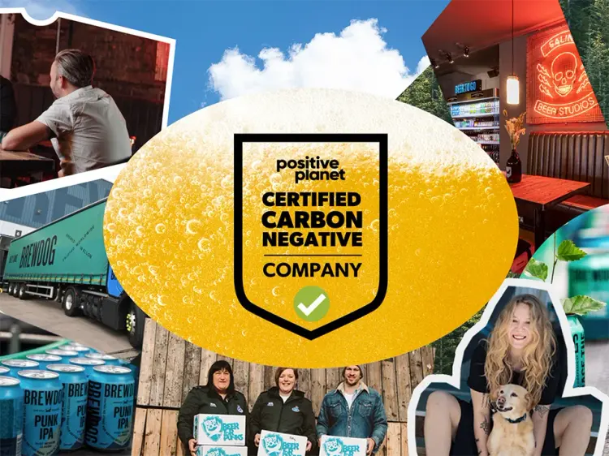

**Figure 11: BrewDog’s Certification**

(Source: BrewDog, 2023)

* As of 2020, BrewDog has paved the way towards making great beer without costing the planet by setting a roadmap towards zero operational emissions (BrewDog, 2023).
* This complies with the brand being officially addressed as a “Positive Planet Certified Carbon Negative” brand based on their measurement of carbon footprint.
* Additionally, BrewDog is identified to be indulging in investing towards high-quality carbon removals while making stone-cold commitments towards future reductions.

Sustainability practices by BrewDog are focused on purchasing 9,308 acres of plot in Scottish Highlands in 2020. This is potentially focused towards creating a biodiverse and native broadleaf woodland and pulling the carbon from the surrounding atmosphere to save the planet (BrewDog, 2023). Reports of 2022 also highlight the brand planting their trees and embracing large reforestation and peatland restoration projects in UK.

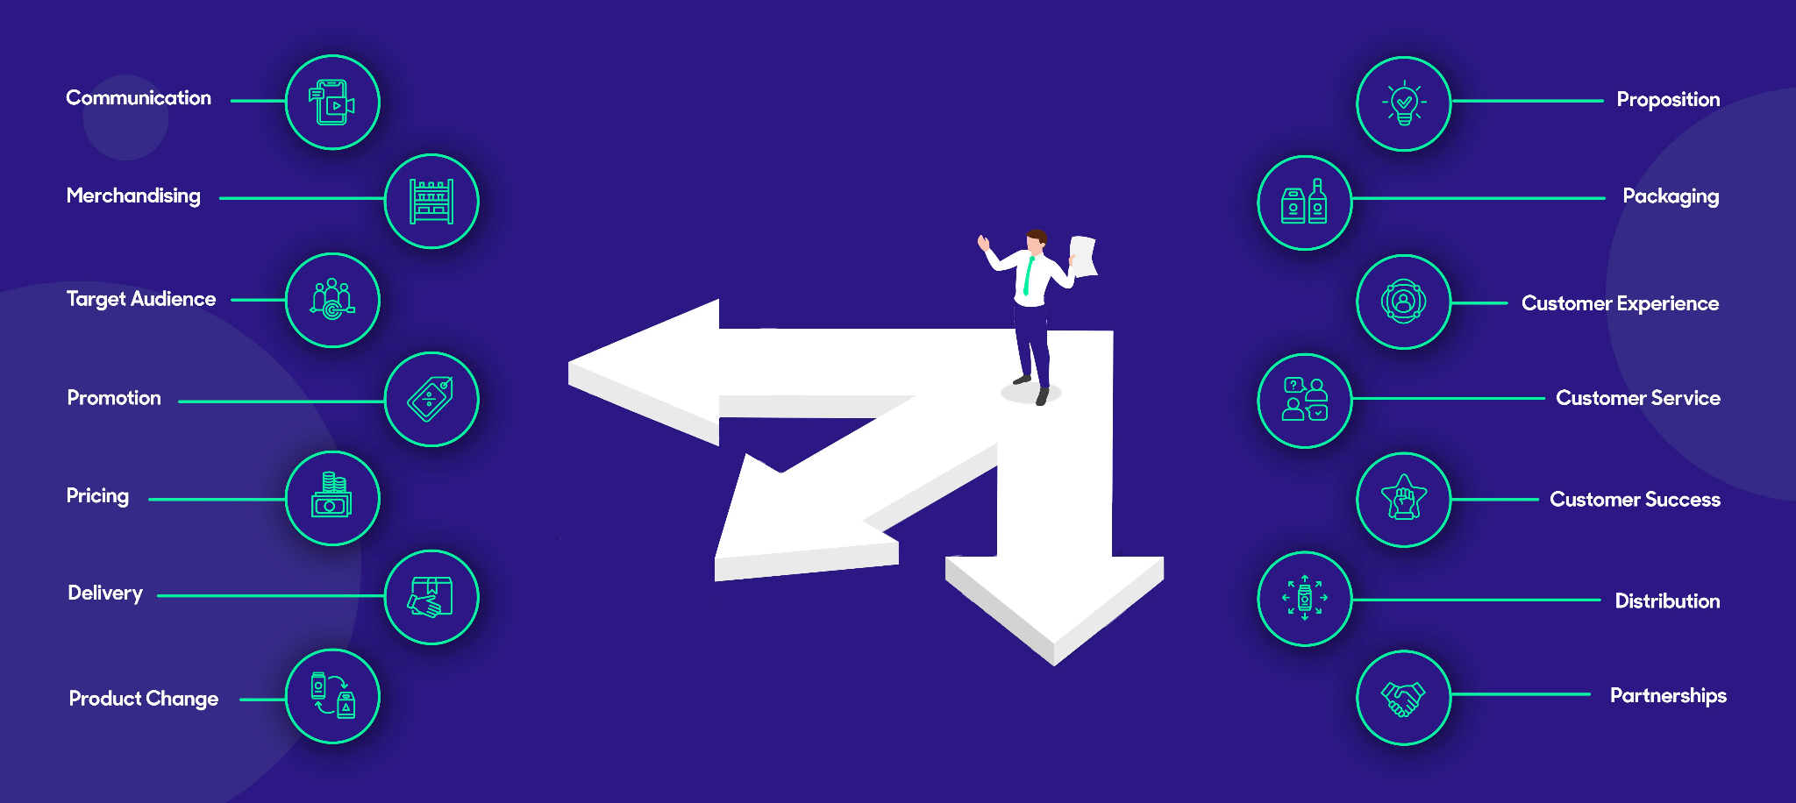

**Figure 12: Partnerships of BrewDog**

(Source: Arenson, 2021)

* BrewDog is also focusing on opening a £12 million eco-friendly brewing facility with a bio-energy plant filling the production of about 176 million pints of craft beer annually (Watt, 2022).
* The following sustainability move for BrewDog is focused towards reducing carbon emissions by about 7500 tonnes.
* It also holds a major opportunity of bringing in an operational investment of £50 million for the company with scope for continuous improvement.

A significant sustainability advantage for BrewDog has been its range of partnerships and “collab culture”. This is in the context of the brand being extremely selective regarding its partnership and emphasising brands that tend to be in line with its mission and causes (Arenson, 2021). It has helped BrewDog in strengthening its brand identity while establishing strong connections with its target audience.

### ii. Possible Key Issues

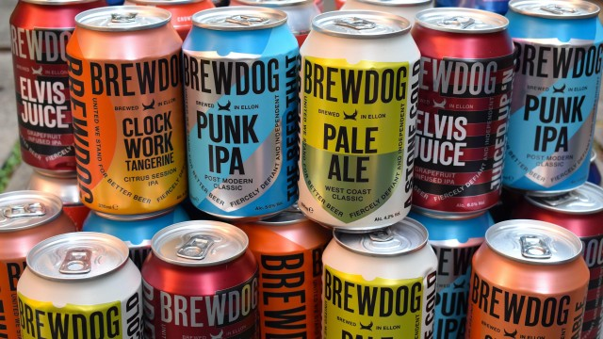

**Figure 13: *“Buy Brands You Love”*** **of BrewDog**

(Source: Bain, 2021)

* A possible challenge for BrewDog can be its corporate governance and toxic workplace culture.
* This is also accompanied by the brand being subject to a range of damaging allegations following a negative impact on the brand image (Bridge House, 2022).
* Moreover, failing to embed the guiding corporate governance principles has paved the way for massively damaging negative publicity in addition to being time-consuming and expensive for addressing the commercial and reputational fallout.

Contrary to these pressing challenges, BrewDog has been identified to be forking out about £9 million towards trying to fix its cultural problem (Boland, 2022). This complies with the move of this brand towards easing pressures on its employees challenged by the facing claims.

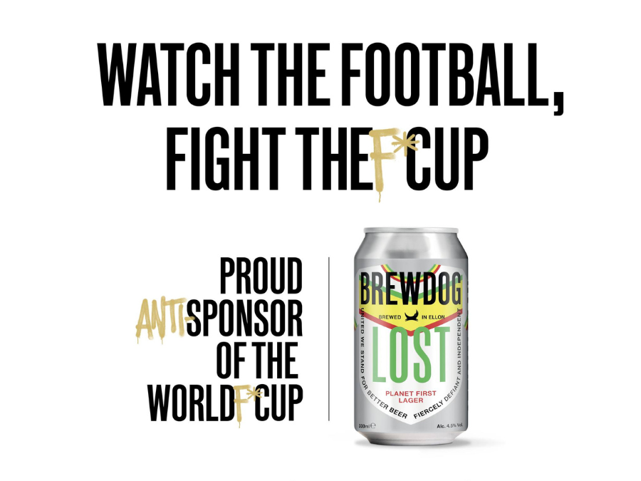

**Figure 14: BrewDog World Cup Controversy**

(Source: Taylor, 2022)

* A potential challenge also lies with the fact that the crisis faced by BrewDog serves as a cautionary tale towards following the advice of *“buy brands you love”* (Bain, 2021).
* The same is also accompanied by the involvement of B Lab associated with its kitemark reviewing the brand.

The following move highlights the risk of BrewDog and the doubt about its future endorsements by customers and investors. An example of this includes the public stand of this British brewer against the host country in the World Cup backfiring with reports of acquisitions by former employees (Taylor, 2022).

## c. Conclusions and Recommendations

### i. Things Done Currently

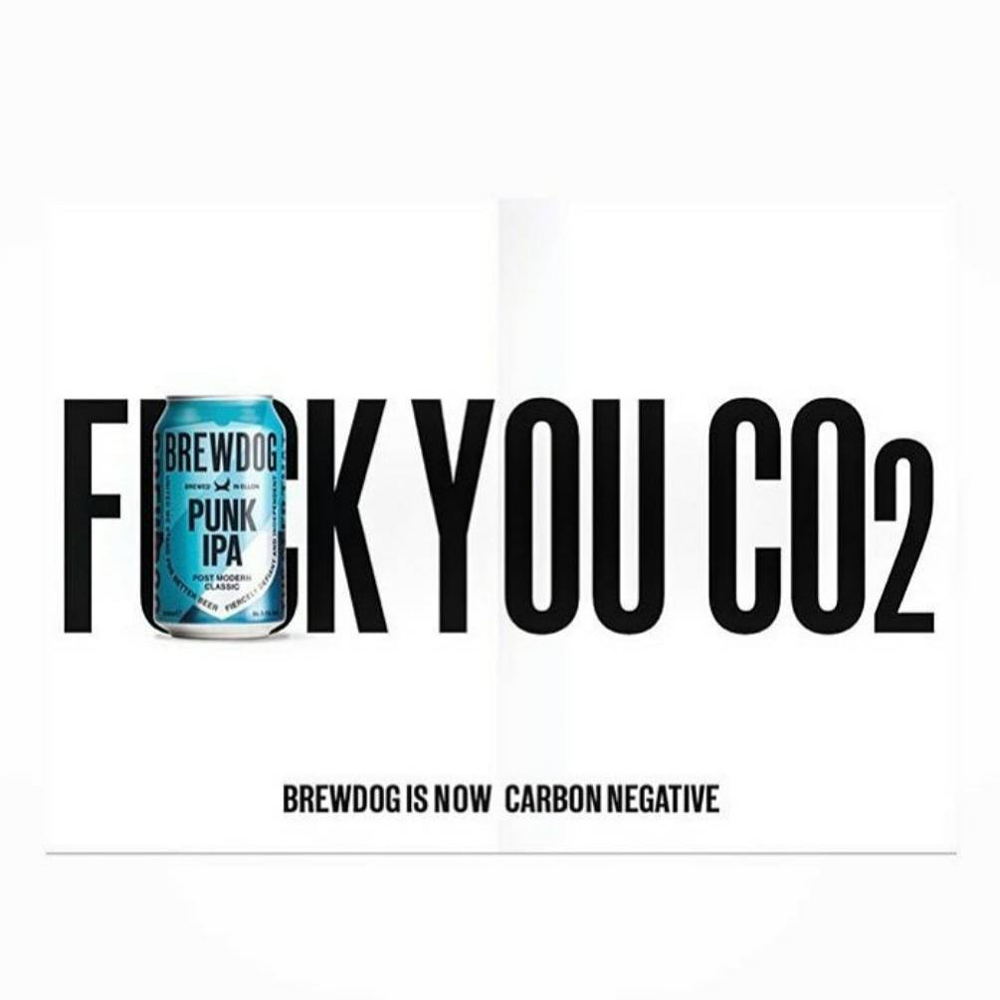

**Figure 15: BrewDog’s Carbon Footprint Effort**

(Source: Saxon, 2022)

* A potentially positive attribute undertaken by BrewDog is its inspirational effort towards reducing its carbon footprint and relevant steps for minimising and mitigating its emissions (Saxon, 2022).
* It is following the brand and also playing a relevant critical leadership role towards encouraging other associated businesses for doing the same.
* BrewDog is also accounting for setting exemplary standards concerning its sector by posing as a great example for others.

The “Positive Planet Carbon Negative Accreditation” Accounts for setting high standards for a range of organisations demonstrating a commitment towards reducing their footprint. collaboration of this with BrewDog holds the scope for offsetting about 120% of their existing emissions and rendering a positive sustainability and societal impact.

### ii. Things to be Considered Differently

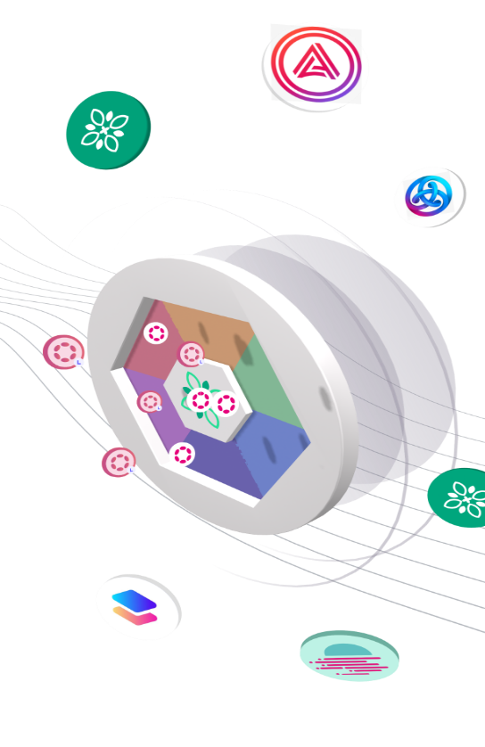

**Figure 16: TapIO**

(Source: Brewer World, 2019)

* A considerable disruption required for BrewDog is technology as a way of streamlining operations.
* This is relevant to the potential implementation of Artificial Intelligence and Internet of Things solutions for helping with maximising output (Brewer World, 2019).
* The following can also prove beneficial for the brand in optimising labour, improving efficiency, and boosting profit without compromising on quality.

### iii. Key Competitive Threats

* A concerning threat for BrewDog can be extensive resilience towards adopting flexible and innovative business models for value addition.
* As per the views of Singh *et al*. (2022), the implementation of innovative measures requires business ecosystems that can encourage co-creative engagement.
* The considerable gaps can also involve potential market threats from other established brands like *Heineken* and *Carlsberg*.

Besides this, climate changes, pandemics, altering consumer demand preferences, and technology also tend to alter beer supply chains. Although brewery software and innovative technology can account for improving brewing processes, quality control, delivery, and inventory management, frequent updates can impose challenges (Rawat, 2022).

# 5) Reflective Evaluation

## a. Possible Challenges Encountered

* Identification of assumptions
* Letting my conscious or unconscious assumptions get unexamined and unaddressed

All research works tend to be conducted under certain forms of assumptions. According to Verma and Abdel-Salam (2019), the accuracy and validity of the findings are highly dependent on the role of an individual in fulfilling all the associated assumptions. Conversely, a challenge I witnessed as part of this project work was failing to maintain my assumptions and note them down for questioning my outcomes.

## b. Things to be Done Differently

* Kicking things off by getting all stakeholders together and addressing assumptions of everyone.
* Having a detailed insight into existing knowledge and subsequent assumptions.

I would need to take note of the assumptions of every individual on my team regarding a certain research topic and their source regarding prior data, instincts, previous research and others. This would also prove helpful for me in testing my assumptions throughout the project work while also seeking help from any form of a figure of trust.

# Reference List

Aguinis, H. and Solarino, A.M., (2019). Transparency and replicability in qualitative research: The case of interviews with elite informants. *Strategic Management Journal*, *40*(8), pp.1291-1315.

Arenson, R. (2021). *Why BrewDog's latest move is winning over people’s hearts*. Available at: <https://www.proquoai.com/blog/why-brewdog-is-winning-over-peoples-hearts> [Accessed on: 13 April 2023]

Armstrong, M. (2019). *Craft Beer: The Incredible Crowdfunded Growth of BrewDog*. Available at: <https://www.statista.com/chart/18313/brewdog-growth/> [Accessed on: 10 April 2023]

Bain, I. (2021). *Brewdog’s crisis is a cautionary tale in following the advice to ‘buy brands you love’*. Available at: <https://inews.co.uk/inews-lifestyle/money/brewdogs-crisis-cautionary-tale-buy-brands-love-toxic-culture-1058954> [Accessed on: 14 April 2023]

Boland, H. (2022). *BrewDog spends £9m on trying to fix the culture problem*. Available at: <https://www.telegraph.co.uk/business/2022/05/31/brewdog-spends-9m-trying-fix-culture-problem/> [Accessed on: 14 April 2023]

BrewDog (2023). *BrewDog | Craft Beers | Online Beer Shop |*. Available at: <https://www.brewdog.com/> [Accessed on: 10 April 2023]

BrewDog (2023). *Planet*. Available at: <https://www.brewdog.com/uk/brewdogplanet> [Accessed on: 13 April 2023]

Brewer World (2019). *TapIO – The Disruption The Beer Industry Needs*. Available at: <https://www.brewer-world.com/tapio-the-disruption-the-beer-industry/> [Accessed on: 15 April 2023]

Bridge House (2022). *Brewdog, corporate governance and a toxic culture hangover*. Available at: <https://bhcsecretaries.co.uk/blog/brewdog-corporate-governance-and-a-toxic-culture-hangover/> [Accessed on: 14 April 2023]

Conway, J. (2023). *Leading craft beer brands by sales in the United Kingdom (UK) in 2022*. Available at: <https://www.statista.com/statistics/1121258/leading-craft-beer-brands-by-sales-in-the-united-kingdom/> [Accessed on: 10 April 2023]

Fraser, D. (2021). *BrewDog appoints 'blue-chip reputation' chairman*. Available at: <https://www.bbc.com/news/uk-scotland-scotland-business-58536240> [Accessed on: 10 April 2023]

Karan, R. (2022). *Importance of Teamwork at Workplaces*. Available at: <https://www.shiksha.com/online-courses/articles/importance-of-teamwork-at-workplace/> [Accessed on: 11 April 2023]

Lester, J.N., Cho, Y. and Lochmiller, C.R., (2020). Learning to do qualitative data analysis: A starting point. *Human Resource Development Review*, *19*(1), pp.94-106.

Makortoff, K. and Davies, R. (2021). *Former BrewDog staff accuse craft beer firms of a culture of fear*. Available at: <https://www.theguardian.com/business/2021/jun/10/brewdog-staff-craft-beer-firm-letter> [Accessed on: 12 April 2023]

Mio, C., Panfilo, S. and Blundo, B., (2020). Sustainable development goals and the strategic role of business: A systematic literature review. *Business Strategy and the Environment*, *29*(8), pp.3220-3245.

Murden, T. (2022). *BrewDog chair attacks HR consultancy as toxic row rages*. Available at: <https://dailybusinessgroup.co.uk/2022/04/brewdog-chair-attacks-hr-consultancy-as-toxic-row-rages/> [Accessed on: 10 April 2023]

Race, M. (2021). *Brewdog: Bosses say management issues are in the past*. Available at: <https://www.bbc.com/news/business-59758169> [Accessed on: 10 April 2023]

Rawat, A. (2022). *Technology Is Taking Over The Brewing Industry By Storm*. Available at: <https://futuredrinksexpo.com/en/blog/insights-64/technology-is-taking-over-the-brewing-industry-by-storm-343.htm> [Accessed on: 15 April 2023]

Samaniya, D. (2022). *Marketing strategy of Brewdog: Great beer that’s great for the planet!* Available at: <https://marqueex.com/marketing-strategy-of-brewdog-great-beer-thats-great-for-the-planet/> [Accessed on: 12 April 2023]

Saxon, M. (2022). *BrewDog is now a Positive Planet Certified Carbon Negative company*. Available at: <https://positiveplanet.uk/brewdog-is-now-a-positive-planet-certified-carbon-negative-company/> [Accessed on: 15 April 2023]

Si, S. and Chen, H., (2020). A literature review of disruptive innovation: What it is, how it works and where it goes. *Journal of Engineering and Technology Management*, *56*, p.101568.

Singh, P., Brown, D.M., Chelekis, J., Apostolidis, C. and Dey, B.L., (2022). Sustainability in the beer and pub industry during the COVID-19 period: an emerging new normal. *Journal of Business Research*, *141*, pp.656-672.

Stone, S. (2020). *BrewDog launches ‘world’s strongest beer’, new craft brewer launches fungi-based range*. Available at: <https://www.morningadvertiser.co.uk/Article/2020/09/18/BrewDog-launches-World-s-strongest-beer-Niall-Keating-gin> [Accessed on: 12 April 2023]

Suazo, R. (2022). *How Heineken disrupted the craft beer market without brewing a new drink*. Available at: <https://www.bundl.com/articles/examples-how-heineken-disrupted-the-craft-beer-market> [Accessed on: 15 April 2023]

Taylor, C. (2022). *Up-and-coming craft brewery launches campaign denouncing ‘corrupt’ World Cup. It backfired and highlighted its history of horrible work culture*. Available at: <https://fortune.com/2022/11/07/brewdog-backlash-over-anti-qatar-world-cup-campaign/> [Accessed on: 14 April 2023]

Verma, J.P. and Abdel-Salam, A.S.G., (2019). *Testing statistical assumptions in research*. John Wiley & Sons.

Watt, J. (2022). *James Watt Discusses New £12M BrewDog Eco-Friendly Plant*. Available at: <https://ceoworld.biz/2022/09/20/james-watt-discusses-new-12m-brewdog-eco-friendly-plant/> [Accessed on: 13 April 2023]